FLOOD MONITORING AND EARLY WARNING
INTRODUCTION
Flood monitoring and early warning systems are essential tools designed to mitigate the devastating impacts of flooding. These systems involve the continuous observation and assessment of meteorological, hydrological, and geographical data to predict, detect, and communicate flood-related risks. By combining real-time data collection, analysis, and dissemination of alerts, they play a crucial role in safeguarding lives, property, and infrastructure in flood-prone regions. Timely warnings enable communities to prepare, evacuate, and take preventive measures, reducing the loss of life and property damage associated with floods. Advances in technology have further enhanced the accuracy and effectiveness of flood monitoring and early warning systems, making them an integral part of disaster management efforts worldwide.
ABSTRACT
Flood monitoring and early warning systems play a pivotal role in safeguarding communities from the devastating impacts of floods. These systems integrate advanced technology, including weather forecasting, river level sensors, and satellite imagery, to continuously monitor environmental conditions. When a potential flood risk is detected, timely alerts are disseminated to authorities and the public through various communication channels, such as mobile apps, sirens, and social media. These warnings not only provide crucial lead time for evacuation and emergency response but also enable communities to take preventive measures, such as reinforcing flood defenses and securing valuable assets. Flood monitoring and early warning systems are essential tools in mitigating the loss of life and property, promoting resilience, and ensuring that communities are better prepared to face the increasing challenges posed by climate change and rising sea levelsData from these sources are analyzed in real-time by meteorologists and hydrologists to assess the likelihood of flooding. When a potential flood risk is identified, early warning messages are disseminated through various communication channels, including mobile alerts, sirens, and television broadcasts, to alert residents in affected areas.. This timely information empowers communities to take precautionary measures such as evacuating to safer locations, moving valuable assets to higher ground, and implementing flood-resistant infrastructure. By providing advance notice, flood monitoring and early warning systems save lives and mitigate economic losses associated with flooding, making them essential tools in disaster preparedness and response.
DESIGN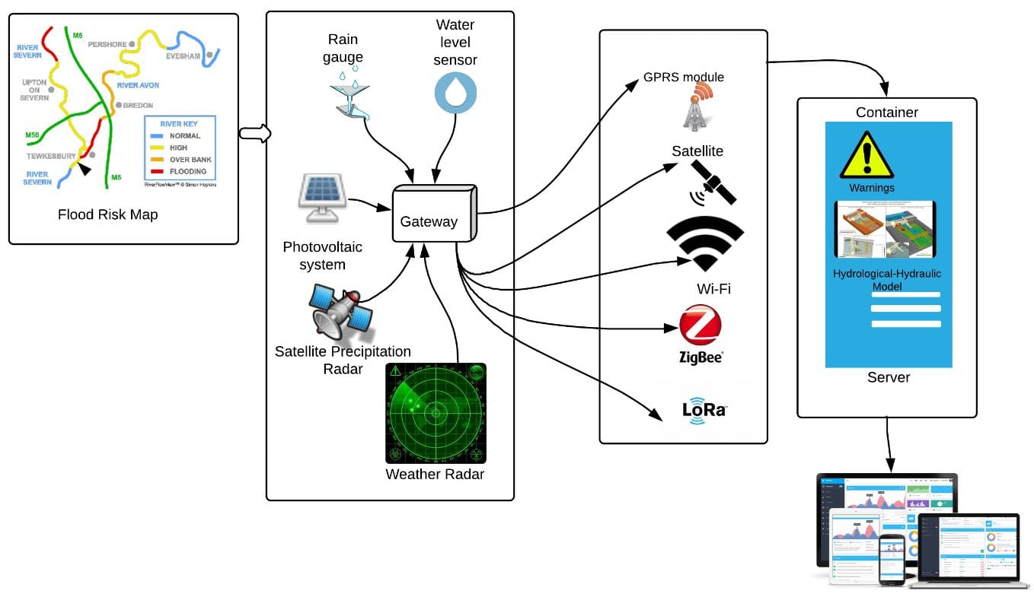

FLOOD SENSOR
Flood sensors are crucial devices designed to detect and monitor water levels in various environments. These sensors employ a range of technologies, including ultrasonic, pressure, or moisture-based systems, to continuously assess water levels and potential flooding risks. When a flood sensor detects rising water levels, it triggers alarms or alerts, providing early warning to individuals, communities, or authorities. This proactive approach helps mitigate the devastating effects of floods by allowing timely evacuation, safeguarding property, and potentially saving lives. Moreover, flood sensors are increasingly integrated into smart home and IoT systems, offering homeowners real-time monitoring and peace of mind, contributing to improved disaster preparedness and resilience in flood-prone regions. Early warning systems are vital tools in safeguarding lives and mitigating disasters. These systems encompass a wide array of technologies and processes designed to detect and predict various threats, such as natural disasters, pandemics, and cybersecurity breaches, well in advance. They rely on data analysis, sensors, and predictive models to provide timely alerts to authorities and the public. Early warning systems not only enable rapid response but also facilitate preparedness and risk reduction measures, ultimately minimizing the impact of crises and emergencies. Whether it's tracking seismic activity, monitoring weather patterns, or detecting emerging health threats, early warning systems play a crucial role in enhancing our resilience and ensuring a safer future. Flood management is a crucial aspect of disaster preparedness and mitigation. It involves a range of strategies and practices aimed at minimizing the impact of floods on communities and their environments. Effective flood management typically includes measures such as the construction of flood defenses like levees and dams, improved urban planning to reduce flood risk, early warning systems, and emergency response plans. Additionally, sustainable land use practices and wetland preservation play essential roles in flood management, as they can help to absorb excess water and reduce the severity of flooding. Overall, a comprehensive approach to flood management is essential to protect lives, property, and ecosystems in flood-prone areas.
RELATED IMAGES

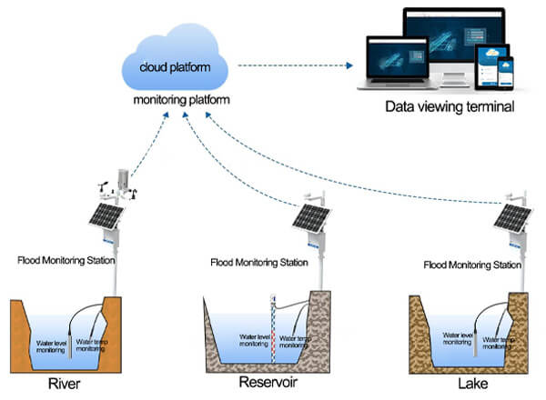

CONCLUSION
In conclusion, flood monitoring and early warning systems play a pivotal role in mitigating the devastating impact of floods on both human lives and infrastructure. These systems employ advanced technology and data analysis to provide timely alerts, giving communities crucial time to prepare and evacuate if necessary. As climate change continues to increase the frequency and severity of floods, the importance of investing in and improving these monitoring and warning systems cannot be overstated. By embracing innovation and collaboration, we can work towards a future where flood-related disasters are minimized, and lives are saved

THANK YOU.

